**Name: Ashish Mukherjee**

**Class: LY CSE NS –‘A’**

**Roll No: 2193060**

**Subject: NML**

**Assignment 8**

**Objective**: Explain TMN application routing and associated circuits.

# Theory:

TMN routing in the 9500 MPR consists of a 3-port router and associated circuits in the CSM (Control and Switching Module) plus CT screens for configuring automatic (OSPF) and manual(static)routing.

Open Shortest Path First(OSPF)

* The preferred method for routing within the radio WANs.
* Uses a simplified OSPF implementation.
* Configuration requires only an A reaI D and Mask.
* Supports redundant WAN paths, allowing linear, tree, ring, mesh and otherWANtopologies.Ifredundantpathsareavailable,OSPFcanreconfigureroutes to work around a failed link.
* Dynamically assigns a routing metric to redundant paths based on route cost, where the route cost is determined by the speed of the interface used and the hop count to a destination.
* Does not perform route aggregation.
* Supportsamaximumof250routeswithinasingleOSPFarea.

Static Routing

* Usually used at radio WAN border routers to specify a default gateway to: A) use for reaching external networks when the external network does not use a supported dynamic routing protocol.

B) control the exchange of dynamic route information between the radio WAN and the external network.

* Static routing only supports provisioning a single route to a given destination at any radio. Route metrics and redundant routes are not supported. This limits the useful WAN topologies to linear and tree configurations when using Static Routing.
* Maximumof25staticrouteentries per radio.

1. To minimize the number of static

Route entries required ,the radio network addressing plan should allow for maximum route aggregation.

1. StaticroutesdirectedoutthePPPinterfacesusetheinterfacenameastheroute destination;rf,rptr,or (front)ppp.

NETMN_RFPortScenarios -

* NETMN_RFPortBelongstoSubnet2
* NETMN_RFPortBelongstoSubnet1
* NETMN_RFPortBelongstoSeparateSubnet3

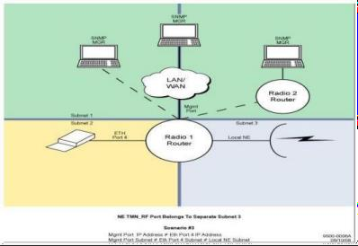

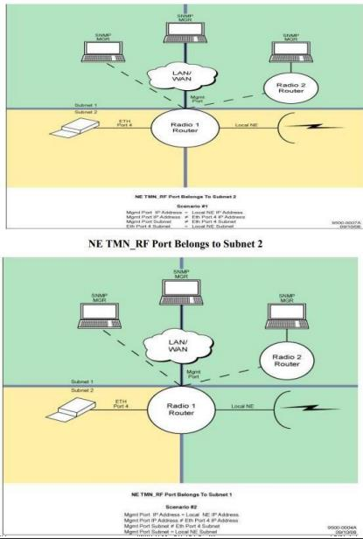

# Conclusion:

We have seen what is TMN application routing and associated circuits with it. Also, the techniques to route which were OSPF and Static Routing.